My name is Daniel Rogalski, this is my classroom philosophy. | 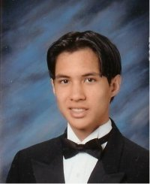
I believe in the many clichés, that children are our future, and that we are one of the most important aspects in their lives and so on.
Because of this, I have a philosophy of creating an open and positive classroom environment. | 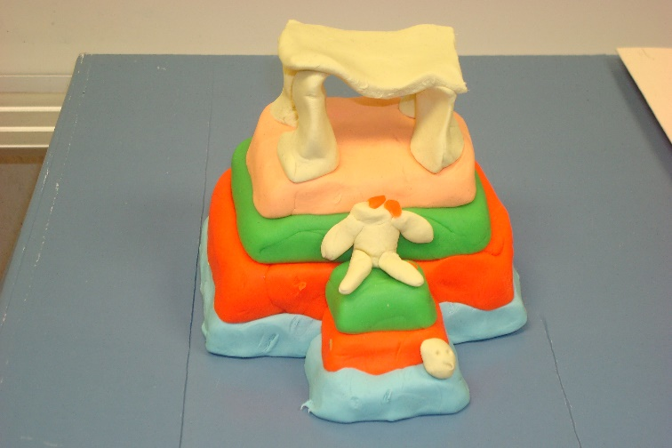
I teach at a school in a low income area. Thus, I’ve learned that students’ home lives may not be very ideal. Thus, no matter my mood during the day, or how I feel about certain students, | 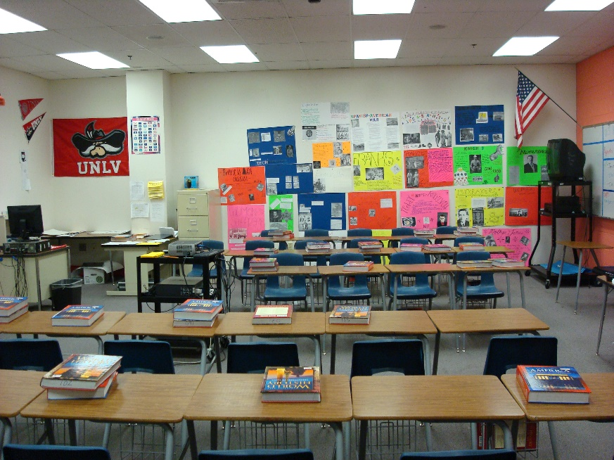
I will always be positive and kind to my students. This way I can show them that they are welcome to learn in my class. | 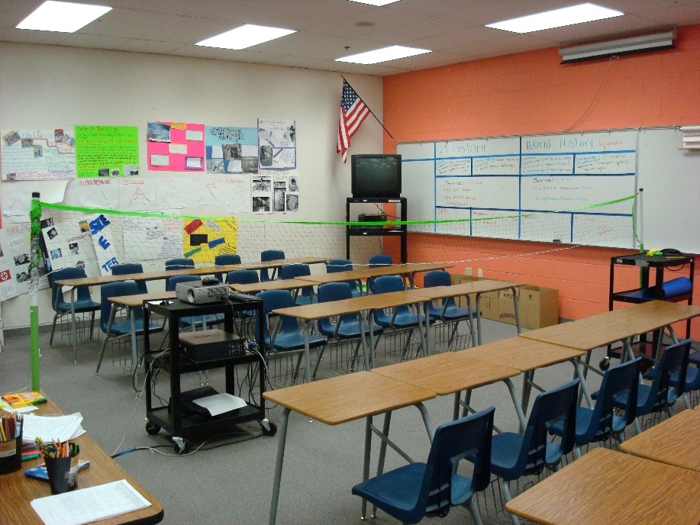
What makes me unique is my ability to have fun with my students. For example, instead of answering questions off the board, I try and make a game of it. | 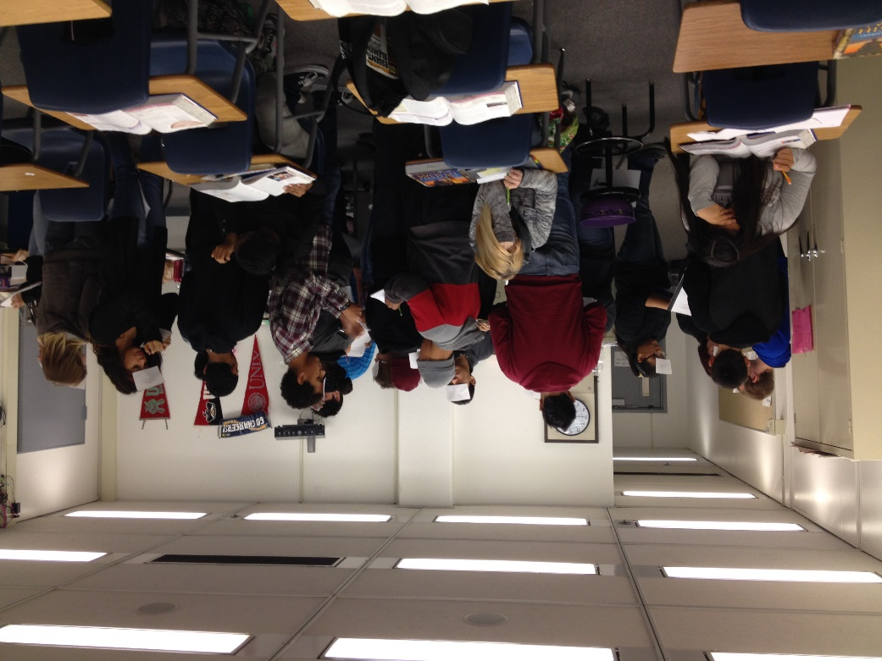
This way they will be more willing to be engaged in learning. It also helps me try to find new ways of creating lessons. | 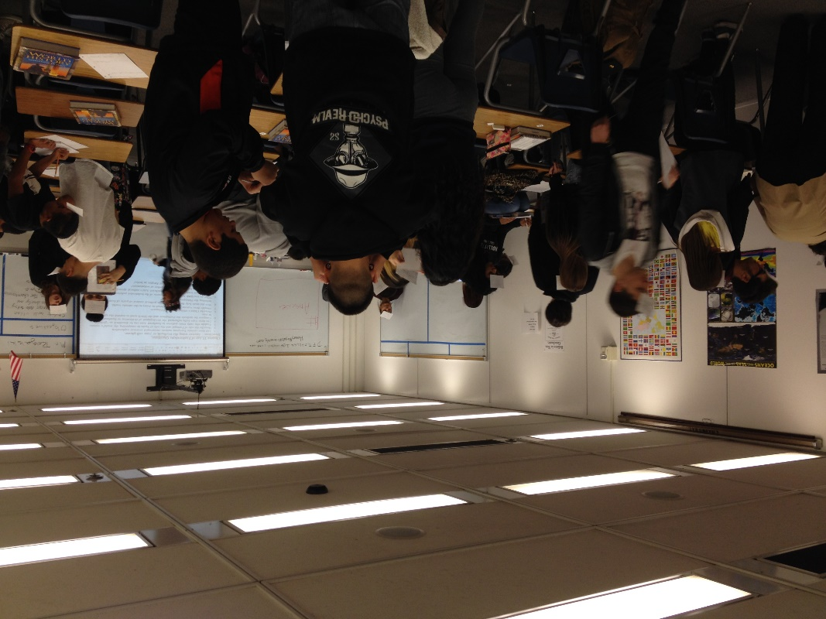
I recall one of my earlier supervisors saying that the best teachers are the ones that keep finding or creating new ideas for their class. | 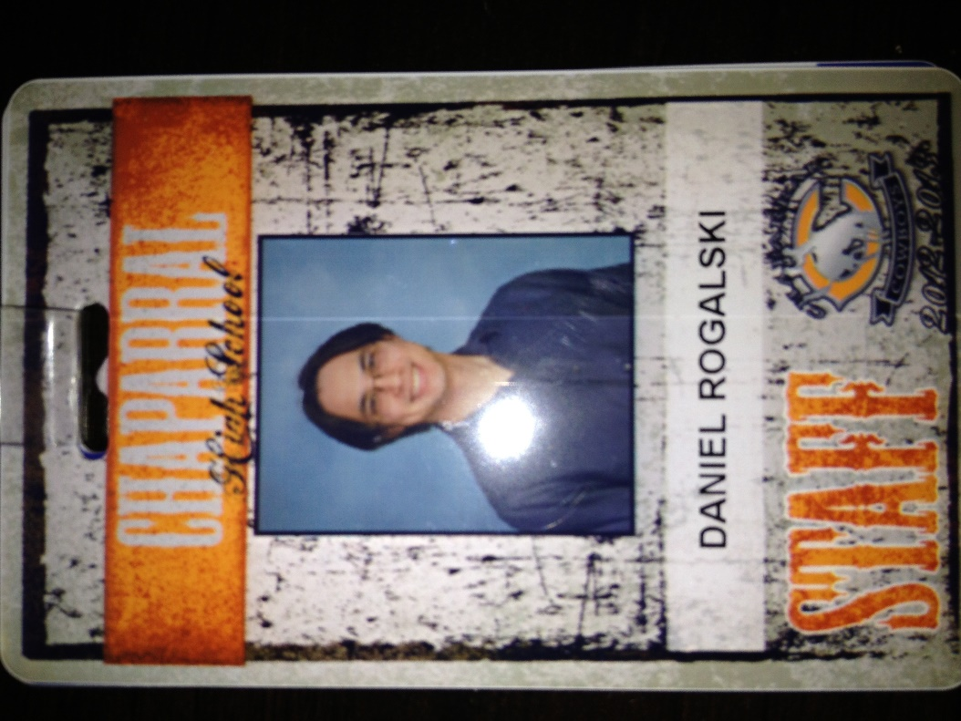
Technology is something that needs to be part of teaching and learning. I enjoy using technology as it opens up a nearly limitless possibilities for learning. I use technology nearly every day in class, whether it is to show a video clip of World War 2 Ships, or a 3D Tour of the Sistine Chapel. | 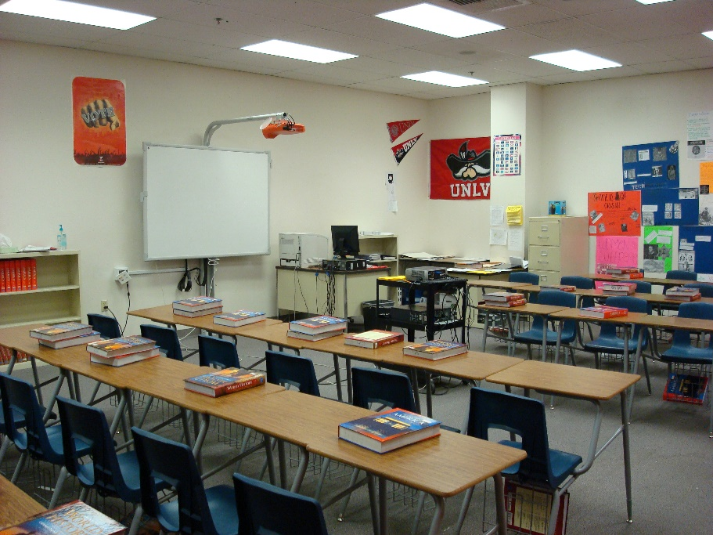
My classroom philosophy is of creating and open and positive classroom environment for my students so that they want to learn and create a better future for themselves and those they care about. | 