Second Life Experience
I created an avatar named GamerG87 in Second Life. I am very familiar with open-world gaming as I am an avid World of Warcraft player. I have a powerful computer build capable of maximizing graphics of any game. Regardless, my experience with Second Life wasn’t a very good one. It was easy to start up and start exploring, but the newer worlds didn’t coincide with the book, as they have been long since deleted. I have played Second Life before in college, and recall having problems with using my laptop. After reading through the Chapter 7 of the book, Web 2.0 How-to for Educators, I decided to try a few of the “islands” that the book mentioned.
The controls and the graphics of the game were not very good. The controls were too constrained and buggy. I would click in the direction to go, and it would take a few seconds for the command to work. The graphics, compared to other games I’ve played, seem to be on par with those from the late 90s, early 2000s. They were not very impressive, and would also take some time to load. This was not a problem of my graphics card, as the GeForce GTX 670 was more than capable of handling these graphics.
I looked for the different “Islands” that the Web 2. Book was mentioning to go visit. None of them are available. I keep getting the message “Your desired location is not currently available. You have been moved into a nearby region.” So the book is a little but outdated. Which is to be expected of a fast-paced and ever changing online world. Similar to the World of Warcraft, Second Life is constantly updating and changing. They do this as a way to keep their users from getting bored and finding other games to play.
I did some exploring of other Islands, in order to find places where I might be able to take my students. I found NPR’s Science Friday to be interesting. It had the NPR radio station playing in the background and different video player hubs around the island. I found an Island made up of 1920s Berlin buildings and music. There was a National History Museum, however it didn’t seem complete and was too buggy. I tried going to the “Urbanization of China” island, but couldn’t move from my initial spot.
I’ve always been fond of video games, and have thought about how I can incorporate them into my lessons for fun. I can see how Second Life can be used in the classroom. Students can be a part of a virtual world where they can interact with other people with explicit knowledge of certain subjects. They can also immerse themselves into roleplaying important events in history, rather than just reading them out of the book. If I had the time and resources, I would enjoy creating a World History Island, where students would take part in important events throughout history.
I would most likely not use this as an educational tool. The resources currently at my school are limited, and the behavior of my students wouldn’t allow it. I’ve already had problems with students with technology and I can see how this can be abused. There were Islands that had an “Adult Theme” and anyone can get in without proper restrictions. I would have trouble with students logging into the wrong islands and not being able to follow simple directions. The technology at my school is limited to a computer lab with computers that are not capable of handling 40+ students playing a graphic heavy game. Also, there weren’t many Islands that were pertaining to a certain part of my content that I could teach, I would have to spend money creating my own, and a lot of time creating the graphics and dialogue for the events. Both are very time-consuming.

Some of the Islands I was able to explore:
NPR Science Friday: 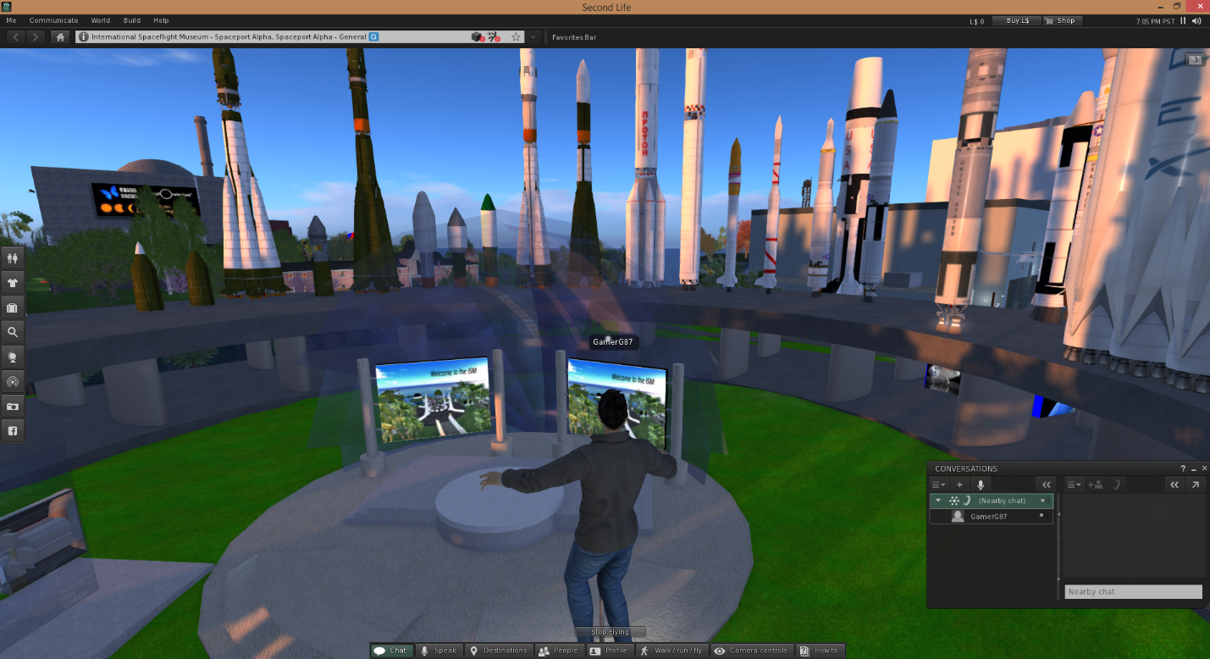
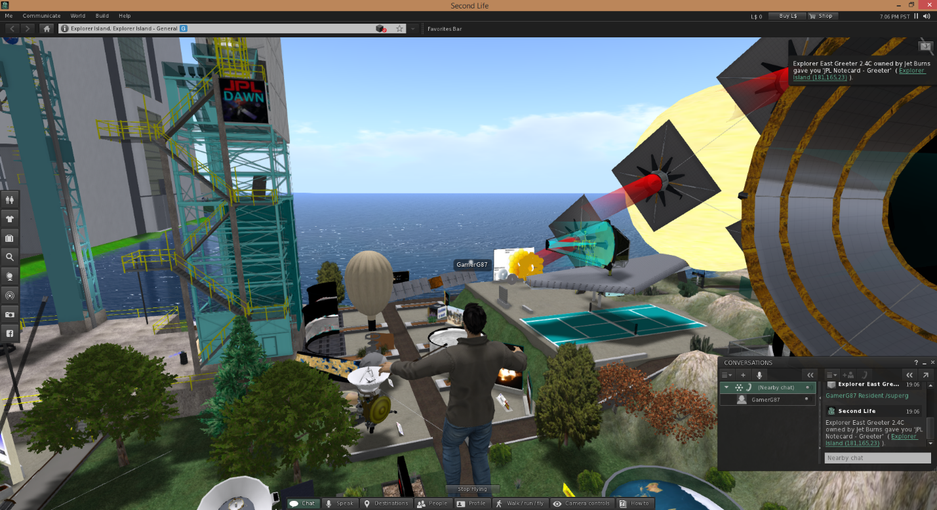

1920s Berlin:
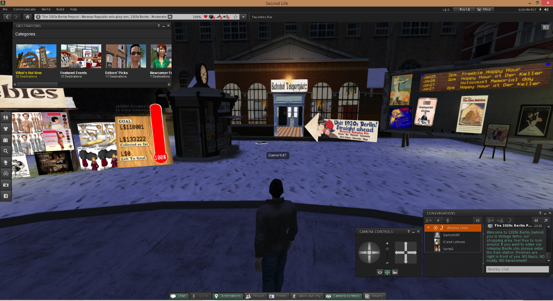
Urbanization of China:
